CI/CD Pipeline assignment –18thJan

1. Jenkins CI CD pipeline for flask application
Step-by-step instructions to install Jenkins on an Ubuntu 22.04 LTS virtual machine, configure Python, install common Python libraries, and verify that Jenkins can run Python jobs.

Jenkins Build Creation Using Docker – Detailed Guide

1. Install Docker
Install Docker on the host machine where Jenkins will run.
Linux:
sudo apt update
sudo apt install -y docker.io
sudo systemctl start docker
sudo systemctl enable docker
Verify installation using: docker –version

2. Pull Jenkins Docker Image
Pull the Jenkins LTS image for stability:
docker pull jenkins/jenkins:lts
DockerFile:

# Use the official Jenkins LTS image (Debian-based)
FROM jenkins/jenkins:lts

# Switch to root to install packages / change groups
USER root

# Create 'docker' group if it doesn't exist, then add jenkins user to it.
# The 'getent' check is idempotent and avoids errors.
RUN if ! getent group docker >/dev/null; then groupadd docker; fi \
&& usermod -aG docker jenkins

RUN apt-get update && \
apt-get install -y python3 python3-venv python3-pip && \
apt-get clean

# Switch back to the jenkins user
USER jenkins

# Pre-install plugins (add to/tweak this list as you need)
RUN jenkins-plugin-cli --plugins \
blueocean \
workflow-aggregator \
git \
git-client \
docker-workflow \
configuration-as-code

# Use Jenkins Configuration as Code, but DO NOT pass secrets as build-args.
ENV CASC_JENKINS_CONFIG=/var/jenkins_home/casc_configs/jenkins.yaml

# Add the JCasC file (references env vars provided at runtime)
COPY casc_configs/jenkins.yaml /var/jenkins_home/casc_configs/jenkins.yaml

# Expose ports
EXPOSE 8081 50000
docker-compose.yml:
version: "3.8"
services:
jenkins:
build:
context: .
args:
JENKINS_ADMIN_ID: admin
JENKINS_ADMIN_PASSWORD: admin123
image: local-jenkins:lts
container_name: jenkins
ports:
- "8081:8080"
- "50001:50000"
volumes:
- jenkins_home:/var/jenkins_home
# Allows Jenkins pipelines to run "docker build"
- /var/run/docker.sock:/var/run/docker.sock
restart: unless-stopped

volumes:
jenkins_home:

4. Run Jenkins Container
Run Jenkins
docker compose up --build
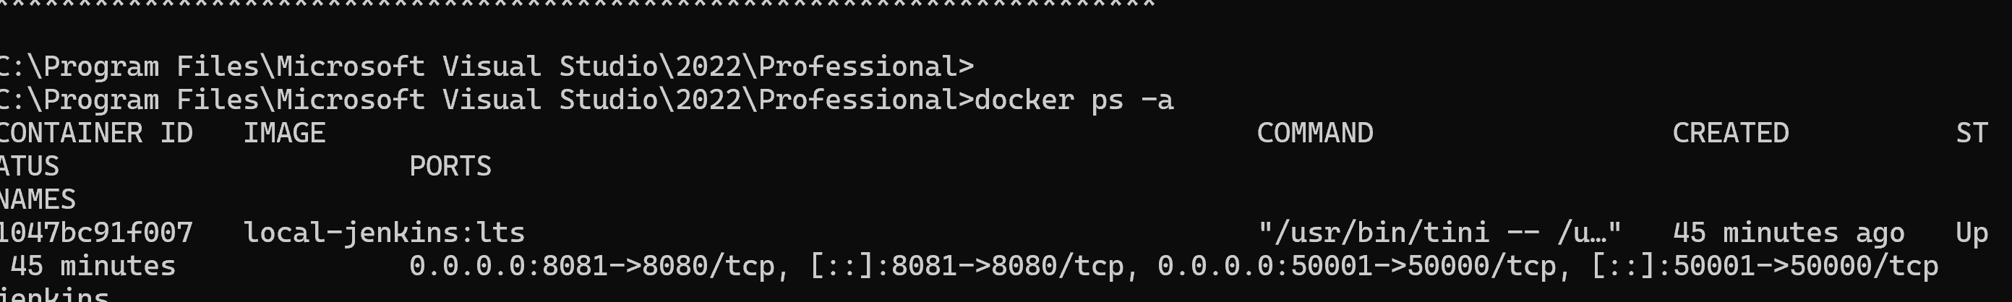

5. Unlock Jenkins
Retrieve the initial admin password:
docker exec jenkins cat /var/jenkins_home/secrets/initialAdminPassword

6. Jenkins Initial Setup
Access http://localhost:8081 in a browser.
Paste the admin password and install suggested plugins.

7. Required Jenkins Plugins
Install the following plugins:
- Git
- Pipeline
- Docker Pipeline

8. Create Pipeline Job
Click New Item → Pipeline → m-b14-jenkins-pipeline → OK.

9. Configure Source Code
Under Pipeline definition, configure SCM or paste Jenkinsfile.

git url: 'https://github.com/manjulachukki/PythonApplicationDemo.git

10. Jenkinsfile

pipeline {

agent any

stages {

stage('Checkout') {

steps {

git url: 'https://github.com/manjulachukki/PythonApplicationDemo.git',

branch: 'main'

}

}

stage('Setup') {

steps {

sh '''

python3 -m venv venv

. venv/bin/activate

pip install -r requirements.txt

'''

}

}

stage('Test') {

steps {

sh '''

. venv/bin/activate

pytest tests || true

'''

}

}

}

}

11. Trigger and Monitor Build
Click Build Now and monitor Console Output for logs.
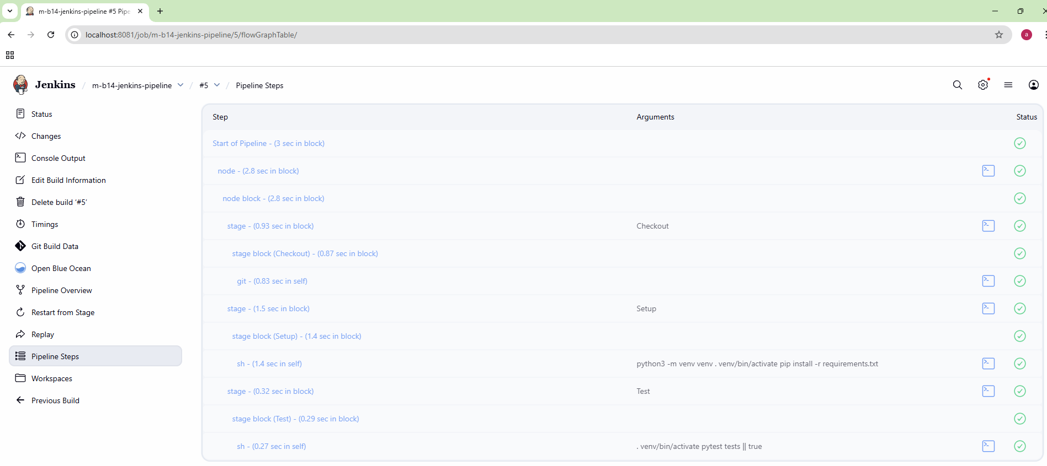
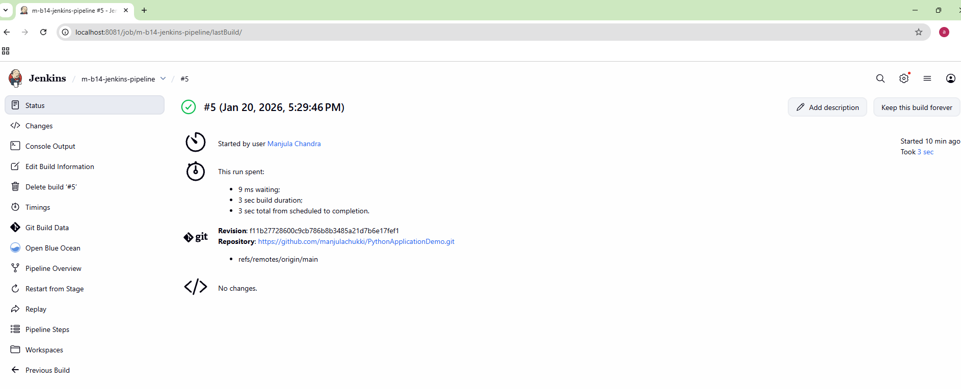
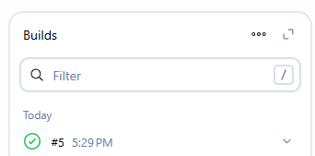
Console output :
Started by user Manjula Chandra

[Pipeline] Start of Pipeline
[Pipeline] node
Running on Jenkins
in /var/jenkins_home/workspace/m-b14-jenkins-pipeline
[Pipeline] {
[Pipeline] stage
[Pipeline] { (Checkout)
[Pipeline] git
The recommended git tool is: NONE
No credentials specified
> git rev-parse --resolve-git-dir /var/jenkins_home/workspace/m-b14-jenkins-pipeline/.git # timeout=10
Fetching changes from the remote Git repository
> git config remote.origin.url https://github.com/manjulachukki/PythonApplicationDemo.git # timeout=10
Fetching upstream changes from https://github.com/manjulachukki/PythonApplicationDemo.git
> git --version # timeout=10
> git --version # 'git version 2.47.3'
> git fetch --tags --force --progress -- https://github.com/manjulachukki/PythonApplicationDemo.git +refs/heads/*:refs/remotes/origin/* # timeout=10
> git rev-parse refs/remotes/origin/main^{commit} # timeout=10
Checking out Revision f11b27728600c9cb786b8b3485a21d7b6e17fef1 (refs/remotes/origin/main)
> git config core.sparsecheckout # timeout=10
> git checkout -f f11b27728600c9cb786b8b3485a21d7b6e17fef1 # timeout=10
> git branch -a -v --no-abbrev # timeout=10
> git branch -D main # timeout=10
> git checkout -b main f11b27728600c9cb786b8b3485a21d7b6e17fef1 # timeout=10
Commit message: "updated jenkins file"
> git rev-list --no-walk f11b27728600c9cb786b8b3485a21d7b6e17fef1 # timeout=10
[Pipeline] }
[Pipeline] // stage
[Pipeline] stage
[Pipeline] { (Setup)
[Pipeline] sh
+ python3 -m venv venv
+ . venv/bin/activate
+ deactivate nondestructive
+ [ -n ]
+ [ -n ]
+ hash -r
+ [ -n ]
+ unset VIRTUAL_ENV
+ unset VIRTUAL_ENV_PROMPT
+ [ ! nondestructive = nondestructive ]
+ uname
+ export VIRTUAL_ENV=/var/jenkins_home/workspace/m-b14-jenkins-pipeline/venv
+ _OLD_VIRTUAL_PATH=/opt/java/openjdk/bin:/usr/local/sbin:/usr/local/bin:/usr/sbin:/usr/bin:/sbin:/bin
+ PATH=/var/jenkins_home/workspace/m-b14-jenkins-pipeline/venv/bin:/opt/java/openjdk/bin:/usr/local/sbin:/usr/local/bin:/usr/sbin:/usr/bin:/sbin:/bin
+ export PATH
+ VIRTUAL_ENV_PROMPT=venv
+ export VIRTUAL_ENV_PROMPT
+ [ -n ]
+ [ -z ]
+ _OLD_VIRTUAL_PS1=$
+ PS1=(venv) $
+ export PS1
+ hash -r
+ pip install -r requirements.txt
Requirement already satisfied: flask==3.0.0 in ./venv/lib/python3.13/site-packages (from -r requirements.txt (line 1)) (3.0.0)
Requirement already satisfied: pytest==7.4.4 in ./venv/lib/python3.13/site-packages (from -r requirements.txt (line 2)) (7.4.4)
Requirement already satisfied: Werkzeug>=3.0.0 in ./venv/lib/python3.13/site-packages (from flask==3.0.0->-r requirements.txt (line 1)) (3.1.5)
Requirement already satisfied: Jinja2>=3.1.2 in ./venv/lib/python3.13/site-packages (from flask==3.0.0->-r requirements.txt (line 1)) (3.1.6)
Requirement already satisfied: itsdangerous>=2.1.2 in ./venv/lib/python3.13/site-packages (from flask==3.0.0->-r requirements.txt (line 1)) (2.2.0)
Requirement already satisfied: click>=8.1.3 in ./venv/lib/python3.13/site-packages (from flask==3.0.0->-r requirements.txt (line 1)) (8.3.1)
Requirement already satisfied: blinker>=1.6.2 in ./venv/lib/python3.13/site-packages (from flask==3.0.0->-r requirements.txt (line 1)) (1.9.0)
Requirement already satisfied: iniconfig in ./venv/lib/python3.13/site-packages (from pytest==7.4.4->-r requirements.txt (line 2)) (2.3.0)
Requirement already satisfied: packaging in ./venv/lib/python3.13/site-packages (from pytest==7.4.4->-r requirements.txt (line 2)) (25.0)
Requirement already satisfied: pluggy<2.0,>=0.12 in ./venv/lib/python3.13/site-packages (from pytest==7.4.4->-r requirements.txt (line 2)) (1.6.0)
Requirement already satisfied: MarkupSafe>=2.0 in ./venv/lib/python3.13/site-packages (from Jinja2>=3.1.2->flask==3.0.0->-r requirements.txt (line 1)) (3.0.3)
[Pipeline] }
[Pipeline] // stage
[Pipeline] stage
[Pipeline] { (Test)
[Pipeline] sh
+ . venv/bin/activate
+ deactivate nondestructive
+ [ -n ]
+ [ -n ]
+ hash -r
+ [ -n ]
+ unset VIRTUAL_ENV
+ unset VIRTUAL_ENV_PROMPT
+ [ ! nondestructive = nondestructive ]
+ uname
+ export VIRTUAL_ENV=/var/jenkins_home/workspace/m-b14-jenkins-pipeline/venv
+ _OLD_VIRTUAL_PATH=/opt/java/openjdk/bin:/usr/local/sbin:/usr/local/bin:/usr/sbin:/usr/bin:/sbin:/bin
+ PATH=/var/jenkins_home/workspace/m-b14-jenkins-pipeline/venv/bin:/opt/java/openjdk/bin:/usr/local/sbin:/usr/local/bin:/usr/sbin:/usr/bin:/sbin:/bin
+ export PATH
+ VIRTUAL_ENV_PROMPT=venv
+ export VIRTUAL_ENV_PROMPT
+ [ -n ]
+ [ -z ]
+ _OLD_VIRTUAL_PS1=$
+ PS1=(venv) $
+ export PS1
+ hash -r
+ pytest tests
============================= test session starts ==============================
platform linux -- Python 3.13.5, pytest-7.4.4, pluggy-1.6.0
rootdir: /var/jenkins_home/workspace/m-b14-jenkins-pipeline
collected 0 items / 1 error

==================================== ERRORS ====================================
______________________ ERROR collecting tests/test_app.py ______________________
ImportError while importing test module '/var/jenkins_home/workspace/m-b14-jenkins-pipeline/tests/test_app.py'.
Hint: make sure your test modules/packages have valid Python names.
Traceback:
/usr/lib/python3.13/importlib/__init__.py:88: in import_module
return _bootstrap._gcd_import(name[level:], package, level)
tests/test_app.py:1: in <module>
from app.app import create_app
E ModuleNotFoundError: No module named 'app'
=========================== short test summary info ============================
ERROR tests/test_app.py
!!!!!!!!!!!!!!!!!!!! Interrupted: 1 error during collection !!!!!!!!!!!!!!!!!!!!
=============================== 1 error in 0.03s ===============================
+ true
[Pipeline] }
[Pipeline] // stage
[Pipeline] }
[Pipeline] // node
[Pipeline] End of Pipeline
Finished: SUCCESS

2. GitHub Actions CI/CD Pipeline Flask App
GitHub Actions pipeline for a Python application that uses a main branch (production) and a staging branch (pre-production). It runs tests, builds the app, deploys to staging on pushes to staging, and deploys production on release tags.

1. Ensure Branch Structure

1.1 Create Required Branches
- main → Production
- staging → Pre-production / QA

Commands (if staging does not exist):
git checkout -b staging
git push -u origin staging
Protect the main branch by requiring PR reviews and passing checks (CI jobs).

2. Create GitHub Actions Workflow Directory

2.1 Create the directory
mkdir -p .github/workflows

2.2 Create a workflow YAML file
.github/workflows/python-ci-cd.yml

3. Define the GitHub Actions Workflow

3.1 Basic Workflow Triggers
name: Python CI/CD Pipeline

on:
push:
branches:
- main
- staging
tags:
- "v*.*.*"
pull_request:
branches:
- main
- staging

4. Install Dependencies Job

4.1 CI Job (Install + Test + Build)
jobs:
ci:
name: Install, Test, and Build
runs-on: ubuntu-latest

steps:
- name: Checkout Code
uses: actions/checkout@v4

- name: Set up Python
uses: actions/setup-python@v5
with:
python-version: "3.11"

- name: Install dependencies
run: |
python -m pip install --upgrade pip
pip install -r requirements.txt

5. Run Tests Using Pytest

5.1 Add Test Execution Step
- name: Run Tests
run: |
pytest --maxfail=1 --disable-warnings -v

6. Build Step (After Tests Pass)

6.1 Example Build Step
- name: Build Application
run: |
python setup.py sdist bdist_wheel

7. Deploy to Staging (on staging branch)

7.1 Staging Deployment Job
deploy-staging:
name: Deploy to Staging
runs-on: ubuntu-latest
needs: ci
if: github.ref == 'refs/heads/staging'

steps:
- name: Checkout Code
uses: actions/checkout@v4

- name: Deploy to Staging
env:
STAGING_API_KEY: ${{ secrets.STAGING_API_KEY }}
run: |
echo "Deploying to staging..."
./deploy/staging.sh

8. Deploy to Production (on release tags)

8.1 Production Deployment Job
deploy-production:
name: Deploy to Production
runs-on: ubuntu-latest
needs: ci
if: startsWith(github.ref, 'refs/tags/v')

steps:
- name: Checkout Code
uses: actions/checkout@v4

- name: Deploy to Production
env:
PROD_API_KEY: ${{ secrets.PROD_API_KEY }}
run: |
echo "Deploying to production..."
./deploy/production.sh

9. Store Environment Secrets Securely
- Go to Repository → Settings → Secrets and variables → Actions → New repository secret
- Add STAGING_API_KEY, PROD_API_KEY, and any other keys or tokens
- Secrets are encrypted and injected at runtime; never hardcode credentials

